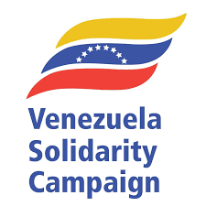

MODEL MOTION - No War on Venezuela!

This branch condemns the actions by the United States government:
- in launching a military attack against Venezuela and kidnapping President Maduro and his wife Cilia Flores and calls for their immediate and unconditional release.
- the killing of 110 people, including 32 Cubans defending the President.
- threatening further military attacks against Venezuela unless control over the country’s oil resources is handed to the United States.
This branch recognises that:
- This is a clear violation of the principles of the United Nations Charter, including the prohibition on the use of force and the principle of non-intervention in the affairs of sovereign states
- As set out in recent US National Security Strategy, this is the implementation of President Trump’s version of the Monroe Doctrine of 1823 which asserts that the whole of the Western Hemisphere should be subservient to the diktats of the United States of America
- The US intervention is aimed at denying the country the right to self-determination and capturing Venezuela’s vast oil reserves – the largest in the world – as well as gold and other resources.
- This is an attack on Venezuelan sovereignty and constitutes a threat to all countries in Latin America asserting their right to self-determination and defending their sovereignty.
This branch calls on the British Government to condemn the actions of President Trump which are a flagrant breach of international law, and to immediately release the $2 billion of gold which they have withheld from the Venezuelan government.
This branch resolves:
- to affiliate to the Venezuelan Solidarity Campaign.
- to make a donation of (£100/£500) to the campaign
- to support initiatives taken by VSC and partner organisations like Stop the War, CND and Cuba Solidarity Campaign to call on the UK Government to oppose the US intervention.

